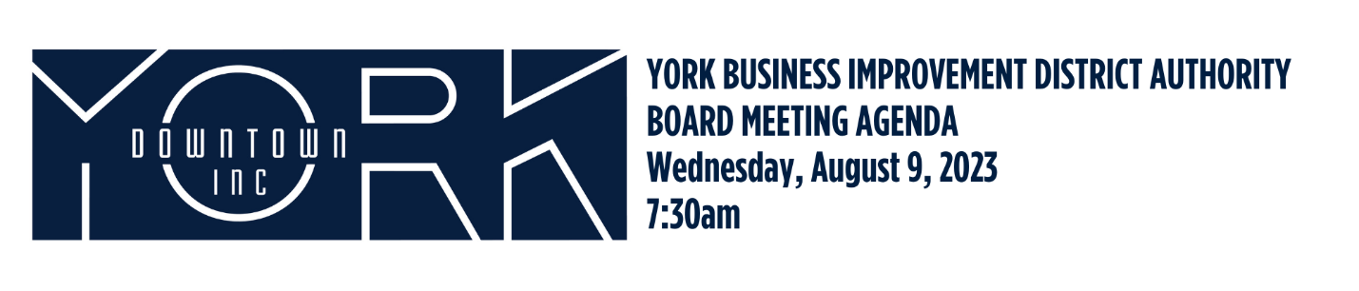
- Call to Order/Welcome Aneury Perez

- Public Comment

- Approval of June 2023 Minutes

- Report on May and June Financials Aneury Perez

- Downtown Development Committee Report Jules Tolbert

- Marketing Updates
  - Sojourn Noir Joanne Wilmore

- New Business

- Old Business

- Adjournment Aneury Perez

Next Board Meeting is Wednesday, October 11, 2023 at 7:30am
Next Executive Committee is September 13, 2023 at 7:30am

