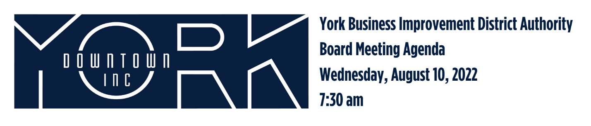
- Call to Order/Welcome Jules Tolbert
- Public Comment
- Approval of June 2022 Minutes
- Report on May and June Financials Aneury Perez
- Downtown Environment Committee Report Eric Menzer
  - Trench Drain Cover Replacement
  - George Street Repairs & Bike Lanes
  - ABM and Funding Sources
  - Wayfinding
- Diversity, Equity, and Inclusion Jonathan Desmarais
  - Downtown BLOOM Grants Update
  - National Night Out
- New Business Jonathan Desmarais
  - Urban Revitalization Manager Hiring
  - 2023 New Board Member Needs
- Old Business
  - Destination Marketing Katie Mahoney
- Adjournment Jules Tolbert

Next Board Meeting is Wednesday, October 12, 2022 at 7:30am

