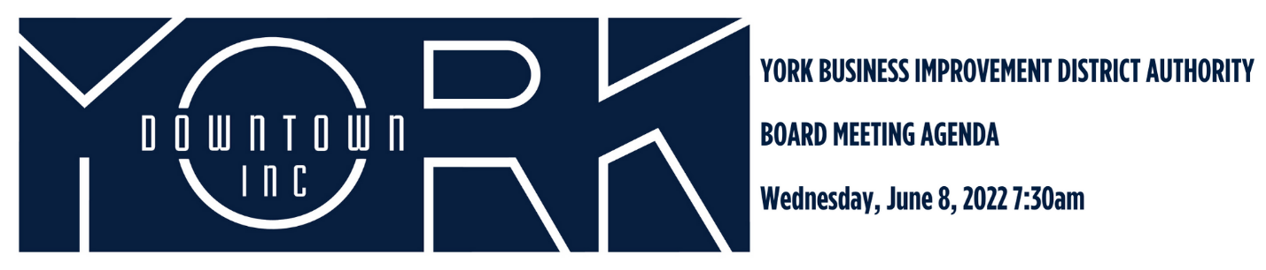
- Call to Order/Welcome Jules Tolbert
- Public Comment
- Approval of December 2021 Minutes and April 2022 Minutes
- Report on March and April Financials Aneury Perez
- Downtown Development Committee Report Jules Tolbert
  - Northern Gateway Project
  - 1 North George Street
  - Other Development Updates
- Diversity, Equity, and Inclusion Britney Brooks
  - First Friday Youth Engagement Initiative
  - Community Engagement
- New Business Jonathan Desmarais
  - National Main Street Now Conference
- Old Business Katie Mahoney/Jonathan Desmarais
  - Give Local York
  - Destination Marketing
- Adjournment Jules Tolbert

Next Board Meeting is Wednesday, August 10, 2022 at 7:30am

