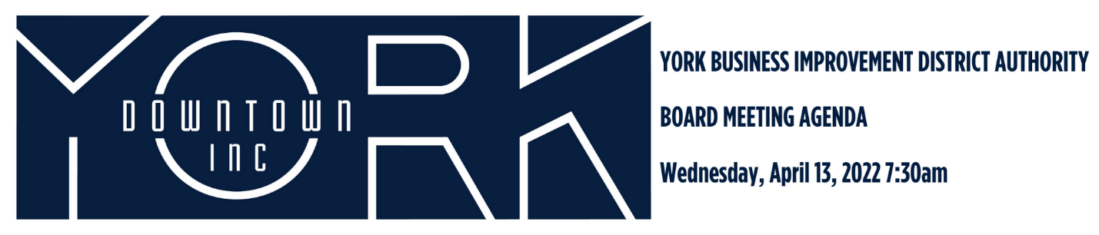
- Call to Order/Welcome Jules Tolbert
- Public Comment
- Review of December 2021 Minutes*
- Report on January and February Financials Aneury Perez
- Downtown Environment Committee Report Eric Menzer
  - Wayfinding
  - Clean-Up Crew
  - Tree Replacement
  - Police Overtime
- Diversity, Equity, and Inclusion Jonathan Desmarais
  - Bloom Empowerment Center
  - Welcoming Community Grants
  - Community Engagement
- New Business Jonathan Desmarais/Casey Nixon
  - Give Local York Narrative and Plans
- Old Business Katie Mahoney
  - Destination Marketing and Plans
- Adjournment Jules Tolbert
*February 2022 was not an official YBIDA Board Meeting with minutes.

Next Board Meeting is Wednesday, June 8, 2022 at 7:30am

