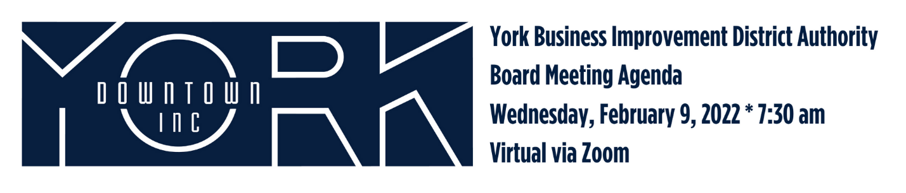
- Call to Order/Welcome Jules Tolbert
  - Welcome Jonathan Desmarais, DI Director
  - Introduction of Downtown Inc Team Members
- Public Comment
- Review of December Meeting Minutes
- Report on November and December Financials Aneury Perez
- Fund Development Committee Report John Klinedinst
  - Give Local York
  - Donors
- Diversity, Equity, and Inclusion Jonathan Desmarais
  - Launch of Bloom Empowerment Center
- New Business Jonathan Desmarais
  - Director of DI 90-Day Plan
- Old Business Jules Tolbert/Katie Mahoney
  - Block by Block Status
  - Destination Tourism Marketing
- Adjournment Jules Tolbert

Next Board Meeting is April 13, 2022, 7:30 am * Hybrid

