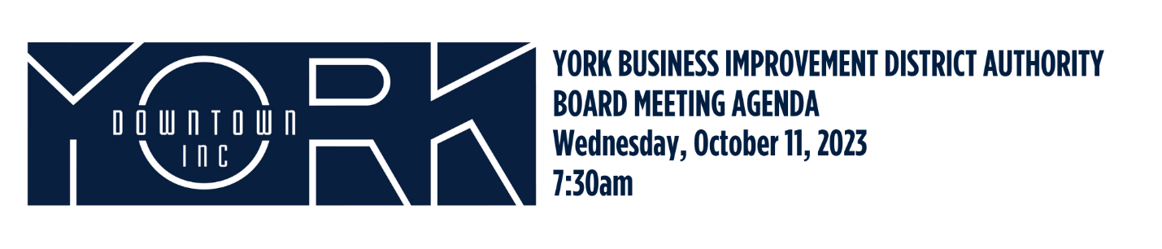
- Call to Order/Welcome Aneury Perez

- Public Comment

- Approval of August 2023 Minutes

- Report on July and August Financials Aneury Perez

- Downtown Fund Development Committee Report John Klinedinst
- New Business
  - 2025 BID Renewal Update Jonathan Desmarais

- Old Business

- Adjournment Aneury Perez

Next Board Meeting is Wednesday, December 13, 2023 at 7:30am
Next Executive Committee is Wednesday, November 8, 2023 at 7:30am

